Steps to install java.

Step 1: Download JDK. ...

Step 2: Install JDK and JRE. ...

Step 3: Include JDK's "bin" Directory in the PATH. ...

Step 4: Verify the JDK Installation. ...

Step 5: Write a Hello-World Java Program. ...

Step 6: Compile and Run the Hello-World Java Program.

Steps to install eclipse:

Double-click the file that you just downloaded, to run it. ...

Click the "I accept the terms...” ...

Click the Next> button. ...

Click the Next> button.

You will see an Installing window (for J2SE Development Kit 5.0 Update 8), whose progress is shown by progress bars (on various panes)

Steps to install workspace

The eclipse workspace contains resources such as –Projects, Files and Folders .

File → New → File

File → New → Folder

what is data type and different data types`

It will represents what type of data we are storing

Int

Char

Long double

Double

Float

String

Boolean

What is variable?

It will store the value in memory

To create variable we specify

Datatype Variablename;

What is main method in java?

Main method is referred as entry point of Java application which is true in case of core java application.

Example for main method:

public class Calculator{

   public static void main(String args[]){

        System.out.println ("I am doing good ");

   } }

Steps to create project?

File -> Project

We call Project is program

How to create .java file/class?

Project -> new class and give extension .java

Class Employee {

How to create packages and what is best way to give name

From solution explorer, select project, right click and select package

Ex: companyname. projectname.foldername (this is common naming standard).

**creating property/data members :**

we create properties at class level

int salary

String firstname

**creating method with void :**

A **Java method** is a collection of statements that are grouped together to perform an operation.

Ex: public void show()

{

//

//

//

}

**Creating method with void and parameter**

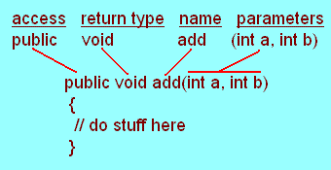

This would be written

public void add(int a, int b)  
 {  
  // do stuff here  
 }

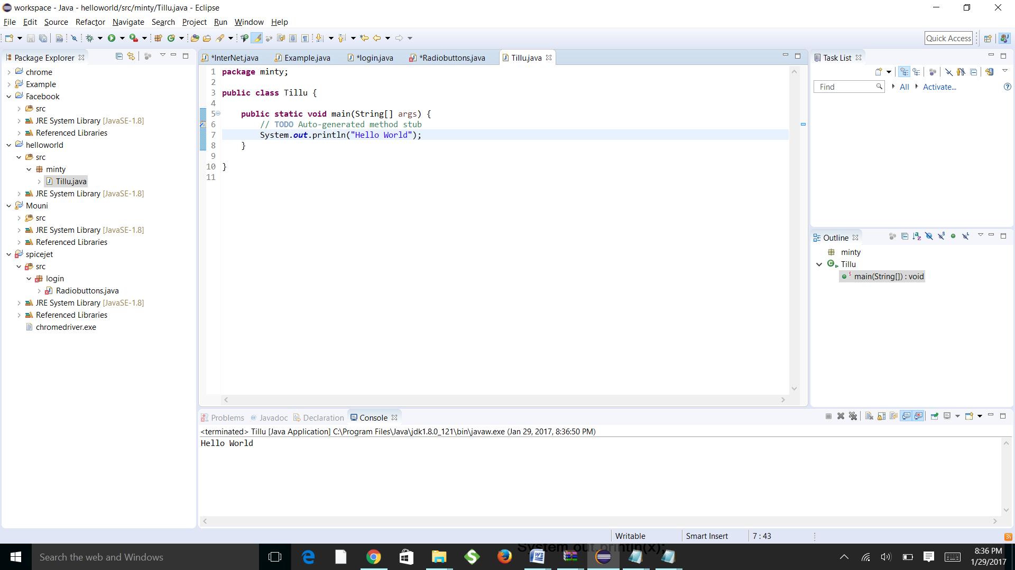

Create static method

The Java construct for implementing functions is known as the static method.

<class-name>.<method-name>

My first class

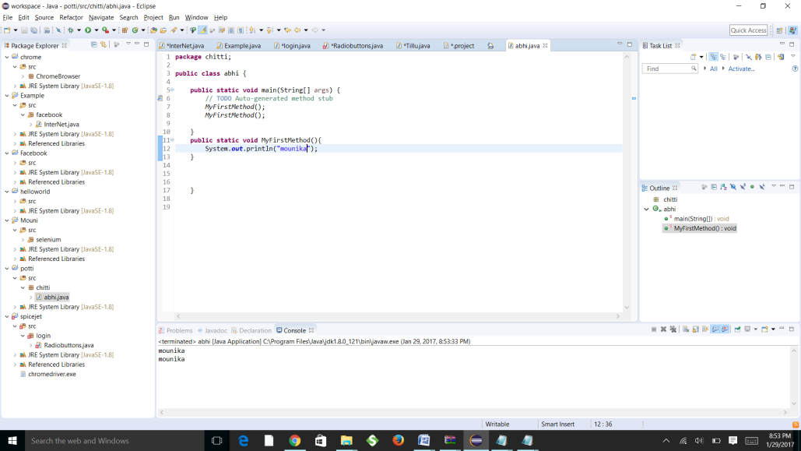

Inheritance poly

package first.java;

public class Inher1poly {

protected int height;

protected int width;

public void set_values(int a, int b) {

height = a ;

width = b;

}

**Inheritance tri**

package first.java;

public class Inher1Tri extends Inher1poly {

public double area() {

return (height* width)/2;

}

}

package first.java;

public class Inher1Rect extends Inher1poly {

//Rectangle class inheriting from polygon class

//poly is derived class and rect is deriving class here

/*if wee are inheriting from base class all protected members

& public members are accessible in derived class */

public double area() {

return (height* width);

}

}

package first.java;

public class Inher1 {

public static void main(String[] args) {

// TODO Auto-generated method stub

Inher1Rect rec = new Inher1Rect();

Inher1Tri tri = new Inher1Tri();

rec.set_values(10, 10);

tri.set_values(10, 10);

System.out.println("Area of rectagle ="+rec.area());

System.out.println("Area of triangle ="+tri.area());

}